This form should be completed, and attached as the cover of each piece of assignment submitted.
STUDENT NAME: Faraj Al-Ansari | PROGRAMME START DATE: October 2019
PROGRAMME TITLE: CIPD 5 | COURSE LOCATION: Doha – Qatar
PERSONAL TUTOR: Mr. Stuart
ASSIGNMENT TITLE: 5DVP_Assessment_Activities
SUBMISSION: 1ST | DATE OF SUBMISSION: 9th November 2019
Before submitting your work to www.bradfield.co.uk please read the following statements and tick all the boxes to show that you have understood and completed what is required.

1. I have read my work through and have checked it for spelling and grammatical errors using, where appropriate, the spell and grammar checker on the computer. | x
2. I have written my name at the top of each page of my work. | x
3. I have numbered each page of my work. | x
4. I have written the word count of my submission at the top of the first page of my assignment. [Where an assignment is split into sections with differing word counts, you should start each new section on a new page and note the word count for the section at the top of the page]. | x
5. I have read and understood the following declaration:
- I confirm that the work/evidence presented for assessment is my own unaided work. | x
- I have read the assessment regulations and understand that if I am found to have ‘copied’ from published work without acknowledgement, or from other candidate’s work, this may be regarded as plagiarism which is an offence against the assessment regulations and leads to failure in the relevant unit and formal disciplinary action. | x
- I agree to this work being subjected to scrutiny by textual analysis software if required. | x
- I understand that my work may be used for future academic/quality assurance purposes in accordance with the provisions of Data Protection legislation. | x
- I understand that the work/evidence submitted for assessment may not be returned to me and that I have retained a copy for my records. | x
- I understand that until such time as the assessment grade has been ratified through internal and external quality assurance processes it is not final. | x
6. I note and understand that the submission of this cover sheet with my  assignment is deemed to be equivalent to my signature. | x

Word count is: 2800 words

Activity 1

1.1 Evaluate what it means to be an HR professional, making reference to the current
CIPD Profession Map.

To be an HR professional, whether using the current or the upcoming Profession Map, it is important to be a critical thinker in order to perform your job effectively.
Critical thinking is important when dealing with employee relations because it enables HR professionals to identify possible problems that may affect productivity. As a result, this approach enables managers to identify the best solution by balancing emotions and logic when solving conflicts. Furthermore, critical thinkers learn from the disagreements and build positive relationships by understanding and eliminating the causes of problems. Therefore, HR department should also recruit critical thinkers to promote the success of the organization.
In addition, HR professionals should focus on developing effective strategies that aim to produce positive outcomes for the organization. As such, we are challenged to continuously update our knowledge and understand the internal and external competitive environment (Francis et al. 2016, p.231). This approach also involves application of effective technologies, using automation too, to support HR systems and processes. Consequently, the actions of HR managers should contribute in increasing profits, especially if the actions are supported by the organization/company.
The map provides a wider illustration on how the HR department adds value and operates (The CIPD Professional Map, 2019). Based on an individual’s experience and qualification, the map also shows HR member roles from all levels. HR global standards are set using the map which also supports them at all stages during their careers. The map has three critical elements;
          - Professional areas
          - Bands and transitions
          - Behaviors
According to (The CIPD Professional Map, 2019), the professional areas focus on what HR practitioners are required to know and do; bands and transitions focus on how HR practitioners can develop from one role to the other; while the behaviors focus on how the activities will be carried out. The HR Map is based on two significant professional areas;
      - Insights, Strategy, and Solutions
      - Leading and Managing
Insights, strategy, and solutions enable HR professionals to establish practicable solutions and insights with main priorities focus around a deeper contextual, organizational, and business understanding. Leading and Managing, on the other hand, provides an insight-led and active leadership that can shape and drive HR professionals.
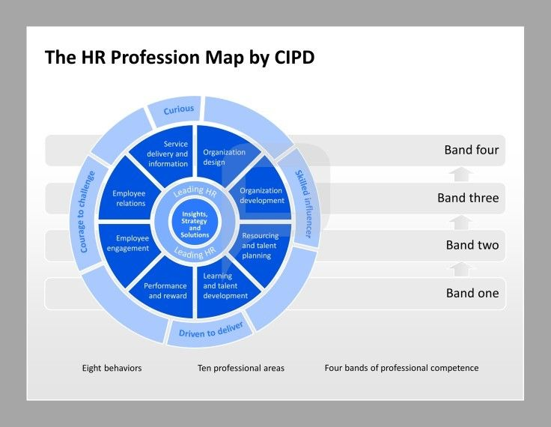
The CIPD Professional Map (2019), states that working in an HR role also requires individuals to consider and acknowledge the eight behaviors and ensure that they work with much effort to achieve them. The eight behaviors include;
- Curious- Curious behavior among HR professionals calls for them to be open-minded, inquisitive, and future-focused hence enabling them to seek out innovative and evolving ways that can be used to add value to the respectful organization.
- Decisive thinker- HR professionals need to illustrate their ability to quickly understand and analyze information and data.
- Skilled influencer- HR professionals are supposed to illustrate their ability to influence diverse stakeholders and gain their support and commitment to achieve organizational value.
- Personally credible- This entails building and delivering professionalism by combining HR practice with commercial to add value to stakeholders, the organization, and peers.
- Driven to deliver- HR professionals demonstrate resourcefulness, purpose, and determination to ensure the organization and its people receive the best results.
- Role model- HR professionals consistently act with independence and impartiality, integrity, legal and organization parameters, and balancing individual.
- Courage to challenge- They are required to demonstrate confidence and courage by skillfully speaking up and challenging others even after being faced with unfamiliar circumstances.
- Collaborative- HR professionals work with a certain range of individuals inclusively and effectively outside and within the organization.

Activity 2

1.2 Briefly describe the elements of group dynamics and give at least two examples of
conflict resolution methods within an HR context.

Team dynamics is a vital aspect in ensuring effective teamwork is achieved and it involves understanding team dynamics from different perspectives including individual temperament and team situation (Bonebright, 2010). To effectively perform the teamwork, several models can be employed by HR professions including the Tuckman team model and Belbin team roles. To start with, the Tuckman team model was proposed by Bruce Tuckman (psychologist) in 1965 and it is presently among the most commonly used theories of team development (Bonebright, 2010). The theory describes 4 stages required to progress through by teams as illustrated in the figure below;
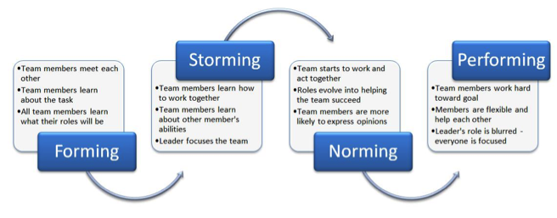
Forming
Here, individuals struggle to form groups while common issues like division of workload, composition, life span, and leadership are solved. Individuals also initialize their acquaintances and personal identities with each other.
Storming
In this element, conflicts begin to surface in the group are the course of the team is changed particularly concerning its reason for formation, roles, and leadership. The importance of this stage is that individuals demonstrate their real motives and identities while trust is also built.
Norming
Here groups set up work patterns and team members also establish issues like harmony, commitment, and structure.

Performing
The group finally starts performing after clearing all the issues. The team is now characterized by productivity, norms, achievement, structure, and culture of the group. The first step after the start of the performance is the team’s focus on accomplishing its goals.
Adjourning
This level was recently added since not all groups have experience in this stage because it is mainly characterized by group demolition. The main reason for adjourning the group could be because the group has accomplished its purpose or when task individuals decide to go their ways.
Examples of Conflict Resolution methods within the HR context
Conflicts are common in most workplaces and this creates the need to understand effective techniques that can be used in conflict resolution especially among HR. Among the conflict resolution methods include mediation and negotiation.
- Negotiation
Negotiation is needed when disputes escalate and it involves placing the desires, opinions, and needs of all involved parties side by side for them to be heard, seen, and considered. Doherty & Guyler (2008), state that is important for individuals to understand the points of view of all involved parties before starting the negotiation to understand whom and what they are dealing with. Individuals also need to explore the interests and position of opposing parties including the wish to resolve the dispute without demonstrating a negative public image (Doherty & Guyler, 2008). This way they can best understand which approach to follow in dealing with the conflict. Individuals should also determine other alternatives like filling a lawsuit or identifying a new partner should the negotiation method fail. Involved parties can brainstorm and invent options that may resolve the dispute to achieve a satisfactory outcome without necessarily using outside parties. In the workplace, however, the HR often take over the dispute and ensure that both parties have reached a consensus and the dispute is resolved.

- Mediation
This conflict resolution technique is common in resolving disputes and it involves the use of a neutral and trained third party to help individuals in dispute to reach a consensus. The trained third party encourages the disputants to better understand the underlying issues being stated and their positions as well (Doherty & Guyler, 2008). This way, the disputants will be able to discover a voluntary, non-binding, and sustainable resolution that will enable them to work separately and together.
Activity 3

With reference to a recent or current project (large or small) which you have led (or
been part of a project team):

2.1, 2.2 Provide evidence of using project management and problem-solving techniques in
the course of the project.

2.3 Explain how you successfully influenced, persuaded and negotiated with others in
the course of the project (or other related activity).

Examples of Project Management and Problem Solving Techniques in the course of the Project
When I was new at my previous workplace, I was put in a project team for three months with the purpose of training and getting to know different roles expected from me as an employee. My team was composed of several people from different ethnicities and cultures but we were able to blend in faster. The quick blend was mainly due to the use of several project management techniques including the work breakdown structure and critical path analysis.
Work Breakdown Structure
In the first place, we were able to use the work breakdown structure to break down the entire learning objective into smaller tasks and sub-tasks (Burke, 2013). We also were able to understand what was required of the learning outcomes in terms of weekly, daily, and hourly periods. For the success of this project management tool, we first listed high-priority deliverables basing on the trainer’s listed objectives and then focused on individual tasks including deliverables needed for each task (see figure below). We then formulated sub-tasks from tasks identified in the initial steps to keep close track of each task. Finally, we formatted and estimated the work breakdown structure on spreadsheets after making several reviews and changes. We then started our team discussions by tackling each task to the granular level through the three months of training. We discovered that our team was in scope, thanks to the work breakdown project management technique.
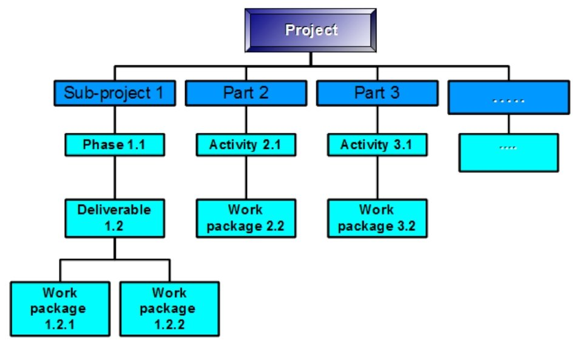
Critical Path Analysis (CPA
The critical path analysis (CPA) was also used in conjunction with the work breakdown structure and it involved planning and mapping out every important task required to effectively complete our training (Burke, 2013). The use of this technique was essential since we had the chance to effectively finish up particular tasks before going to the next tasks. While drawing the CPA chart, we started by listing all activities in the training plan and issuing the starting date and time, estimated finishing periods, and the flow of the tasks as either being sequential or parallel. We then plotted the individual activities using boxes and arrows to give a clear demonstration of specific tasks and when to complete them (see figure below). After completing the chart, we developed an alternative crash action just to ensure, in case the training objectives are not achieved in time. The project came out successful at the end of three months thanks to the two project management techniques.

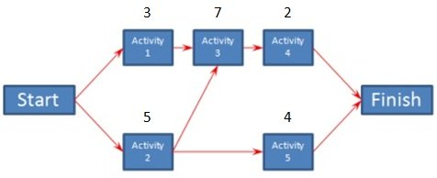

Use of Problem Solving Techniques
The success of the entire project was also attributed to several problem-solving techniques that each member of the team observed. To start with, each tea member engaged in exhaustive research concerning each task and sub-task and presented the findings during discussion periods. Since all of us had gathered some information concerning the topic, it was easy to brainstorm and make concrete points while discussing hence making the project flow fluently. The decision-making technique was also by each team member during the training and we were able to make critical decisions as a group rather than as individuals and this enhanced our confidence in the realized consensus (De Meyer Loch, & Pich, 2002). The success of the team-based decision-making was largely attributed to each team member’s research efforts. Lastly, we engaged in effective and transparent communication throughout the training and that enabled us to raise certain issues and find appropriate solutions. After we got the solutions, we communicated then clearly to the group to avoid the occurrence of misunderstanding and confusion and also making its implementation easier.
Successfully Influence, Persuasion and Negotiation with others in the course of the project
As a team member, I was entitled to actively participate in the discussions and research of the group and in the process, I applied several methods for persuading, influencing, and negotiating with other team members. I successfully negotiated with the team members in the group by finding a common ground where I built up my opinions from a neutral perspective and this enabled the entire team to build trust in me and my opinions. I was also ready for an argument from my team members since they were equally informed on the topics under discussion. Being prepared enabled me to either make counter-attacks or support the arguments with my points of view.
Influencing the team members was also vital during the entire training since the team had to consider my opinions on different topics (Engel & Korf, 2005). To effectively influence them, I first showed them my ability of solve different tasks and sub-tasks of the project hence agreeing with them in most critical aspects. Additionally, I remained persistent throughout the discussions and I often reached out to all team members since some of them disapproved me at first but eventually, they changed their hearts and agreed with most of my opinions.
Mirroring different individuals also allowed me to effectively communicate with them via body language and this gave me a higher advantage while persuading them. The rapport that is built through body language is key to making it easier to persuade my team members (Engel & Korf, 2005). Being among the first people to be chosen for the group, I had great confidence in myself and this made me finding it easier persuading my team members on several key decision-making periods.

Activity 4

3.1 Undertake a self-assessment of one area of your practice to identify your
professional development needs in that area and options to address these.

3.2 Produce a professional development plan (PDP) plan to meet your professional
development needs which includes a justification of the option(s) chosen.

3.3 During your programme, provide a reflective summary of your performance against
the plan. You should also identify any future development needs and record these
in your PDP. [1.1 to 3.2 completed at the beginning of the programme; 3.3 to be
completed now, at the end of the programme].

Undertake a self-assessment of one area of your practice to identify your professional development needs in that area and options to address these.
- Professional Areas
Resources and talent planning- in my HRBP department, we successfully identified and attracted key people to join as HRBPs, who have collaborated and achieved great milestones for the company and HR in general.
Performance and Reward- Working as head, HRBP department, I successfully motivated the entire team and improved the performance of the HRBPs. The organization’s high-performance culture is highly based on such approaches in delivering several key programs like issuing of certificates to specific employees when they make achievements. Additionally, I constantly gave positive feedback to the employees who came to ask for advice or assistance on different issues in the workplace.
- Behavioral Areas
Decisive thinking- I was able to analyze and understand information, knowledge and insights to make recommendations that helped the HRBP area to add different role, which is HRBP Specialist that I consider as a critical management decision that served the best interests of the entire HR rather than the HRBP area alone.
Role model- Basing on the new team of employees that were recently hired in the HRBP area, I provided necessary guidance and acted as a role model, and a coach/mentor to them. I was able to effectively lead a team of new employees while trying out new project management techniques including critical path analysis (CPA). Moreover, I took over one recent intern and a Graduate Developee recruited by the company and reacted appropriately to reflect the company’s vision, mission and values.

Professional Development Plan (PDP) plan to meet my professional development needs including a justification of the option(s) chosen.
What are your long-term development goals? | What are your specific goals in career? | What key skills do you need to accomplish each goal | Actions to be taken (training opportunities) | Time to complete training (months)
Promotion to the next senior management position | -Be the organization’s team supervisor | -Communication techniques and skills  -Leadership skills | -CPD leadership training course (ongoing, CIPD 5) | 6
Promotion to the next senior management position | -Become the organization’s team manager | -Project management skills.  -Leadership skills.  -Management skills | -Presentation skills. Current level is good, but more practice is needed for consistency.  -Project management skills | 12
Promotion to the next senior management position | -Become the organization’s senior manager | -Networking skills.  -Self-management skills.  -Decision-making skills | -Strategic thinking skills.  -Networking skills.  -Decision-making skills | 24

Justification for choosing;
Strategic thinking skills- To effectively understand the future implications that may affect the organization.
Decision-making skills- To enable me to make appropriate decisions concerning the organization’s success, especially during critical times.
Self-management skills- To guide me on how to deal with organizational skills, problem-solving, and time-management.
Leadership skills- To enable me to develop critical techniques in the success of the project including positivity, effective listening, team building, and communication.
Communication techniques and skills- To enable me to engage and interact well with my workmates as well as employees upon the success of the project.
Networking skills- Enable me to develop a positive language and understand who to reach out to and at what particular time.
Presentation skills- Enable me to make good presentations while working as a team manager.
CPD leadership training course- Take advantage of the online course to develop my leadership skills in the workplace.
Reflective summary of my performance against the plan and future development needs and record these in your PDP.
After 6 months of the plan, I should be able to achieve several milestones including gaining necessary leadership techniques. I will also improve my communication skills, especially among my team members. After successful efforts, I will also be able to improve my overall skills. After 12 months, I will have further achievements in my career including having certificates in project management and presentation skills. I will also develop management skills that enable me to have in-depth knowledge on how to manage small-scale projects like those assigned to teams.
Two years later, I am confident to have the potential to become an organization’s senior manager after enhancing my CV and increasing my skills and expertise. In the first place, I should be able to gain strategic thinking techniques which will enable to effectively make plans for the entire organization. I will also gain networking skills that will facilitate the smooth running of the organization. Last but not least, I will gain skills in self-management and this is to play an important role in guiding me on problem solving and skills on time management. No doubt, the personal development plan (PDP) will prove to be successful in helping me achieving my career from a team supervisor to a senior manager in my organization. The success is mainly attributed to the individual tasks that I need to accomplish and the impact they will have on my general skill set and CV.

References
Bonebright, D. A. (2010). 40 years of storming: a historical review of Tuckman's model of small group development. Human Resource Development International, 13(1), 111-120.
Burke, R. (2013). Project management: planning and control techniques. New Jersey, USA, 26.
DE MEYER, A. C. L., Loch, C. H., & Pich, M. T. (2002). Managing project uncertainty: from variation to chaos. MIT Sloan Management Review, 43(2), 60.
Doherty, N., & Guyler, M. (2008). The essential guide to workplace mediation & conflict resolution: rebuilding working relationships. Kogan Page Publishers.
Engel, A., & Korf, B. (2005). Negotiation and mediation techniques for natural resource management (Vol. 3). Rome: Food and Agriculture Organization of the United Nations.
The CIPD Professional Map. (2019). Retrieved from: https://www.cipd.co.uk/learn/profession-map

